

**OCTOBER 10, 2018**

**YOUR FIELD NAME**

**1234 Custom Address**

**City, State 12345 |. 5:00 PM**

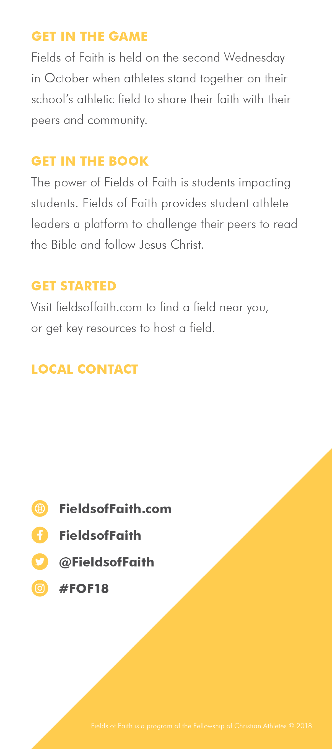

Firstname Lastname

555.555.5555

email@email.com

website